What is a Role?
Role (role definition) is a collection of actions that the assigned identity will be able to perform.
Role definition is an answer to a question “What can be done?”
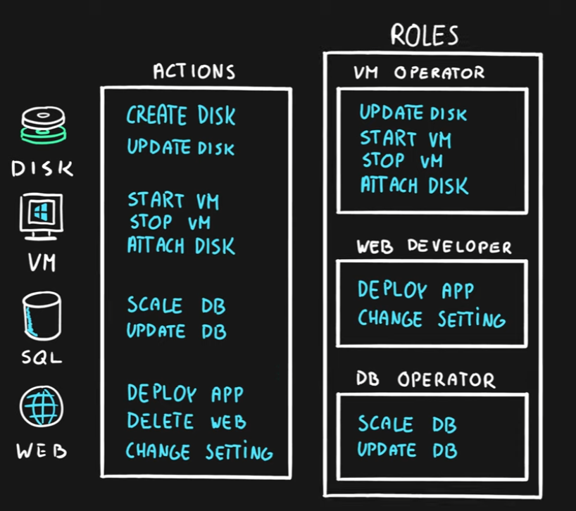

What is a Security Principal?
Security Principal is an Azure object (identity) that
can be assigned to a role (ex. users, groups or applications).
Security Principal assignment is an answer to a question “Who can do it?”
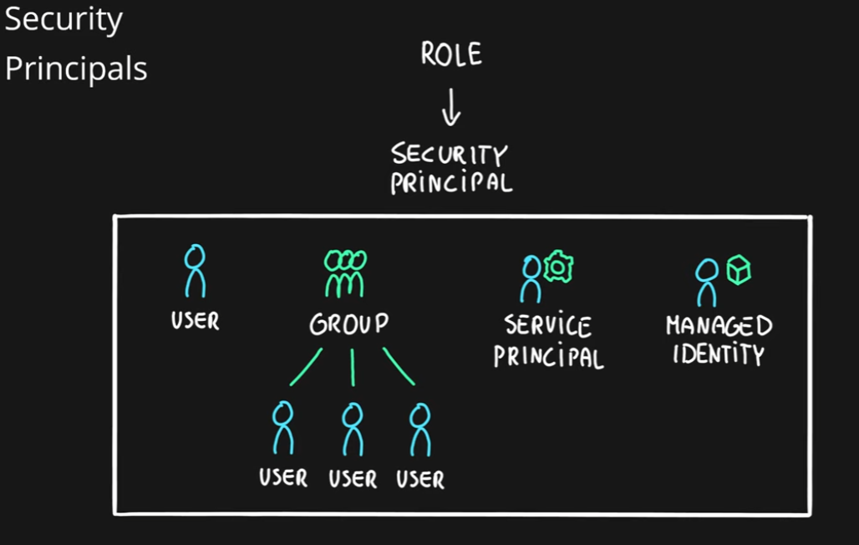
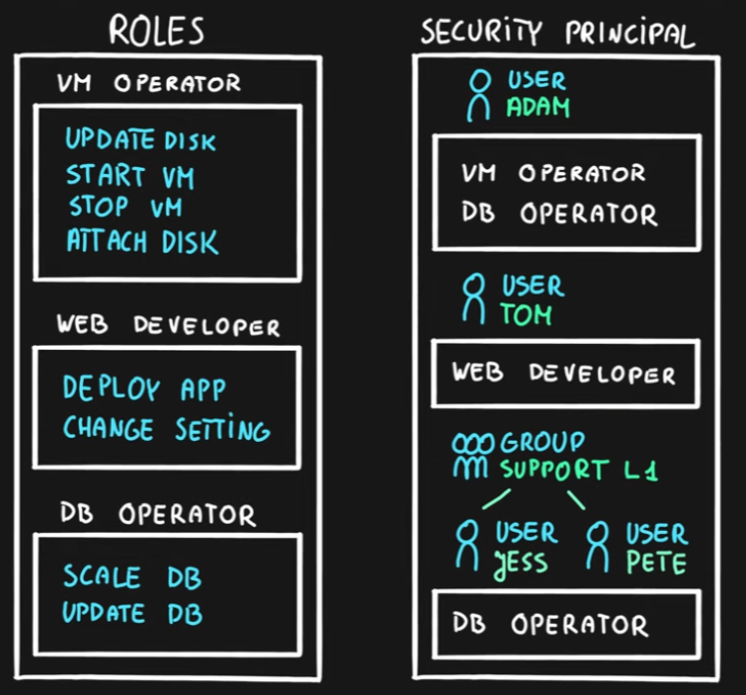

What is a Scope?
Scope is one or more Azure resources that the access applies to.
Scope assignment is an answer to a question “Where can it be done?”
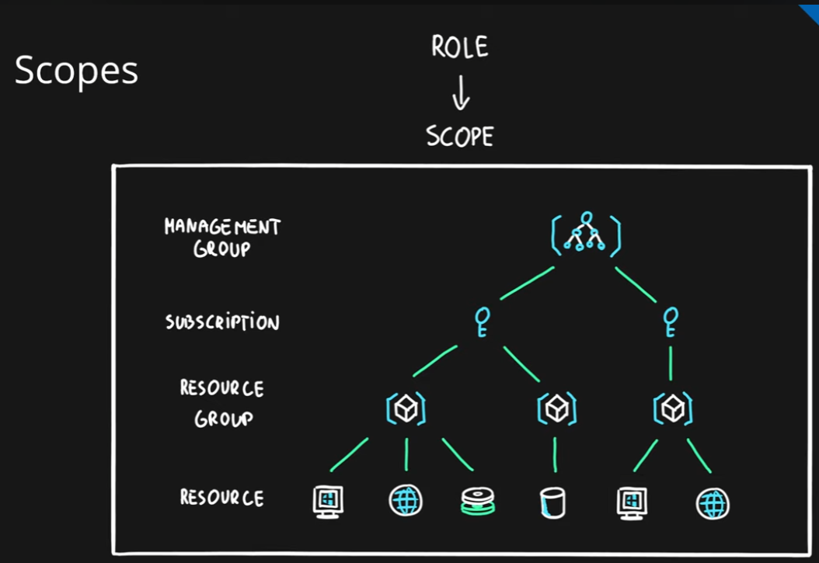

What is a Role Assignment?
Role assignment is a combination of the role definition, security principal and scope
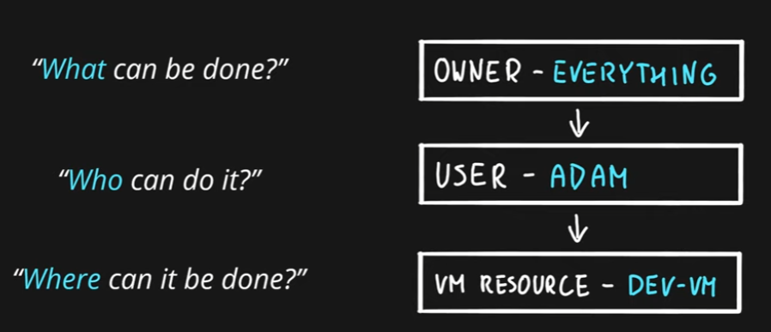

Azure Role-based Access Control (RBAC)
- Authorization system built on Azure Resource Manager (ARM)
- Designed for fine-grained access management of Azure Resources
- Role assignment is combination of
  - Role definition – list of permissions like create VM, delete SQL, assign permissions, etc.
  - Security Principal – user, group, service principal and managed identity and
  - Scope – resource, resource groups, subscription, management group
- Hierarchical
  - Management Groups > Subscriptions > Resource Groups > Resources
- Built-in and Custom roles are supported

